This is a manual explaining the theory behind the algorithm. In summary, each stem is set as the base, filter the potential candidate, compute the score of each candidate and pair the stem with strategies.

Score Computing:  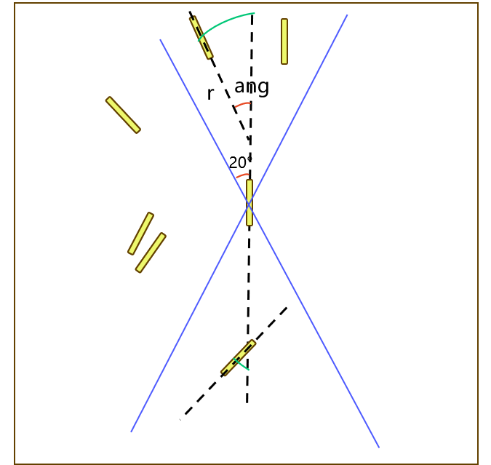  Score = r*ang/conf while r = (stem_center – intersection) – length/2; conf is the effect of length from candidate counted by all stem length, the longer, more convincible in pairing.  So we don’t expect those stem candidates’ center right on the stem vector to have minimum (0) score since the smaller the better. | (1) radius = abs(np.linalg.norm(inter - c2) - (l2[0]+l2[1])/2)/(1 + 1.5 * (conf2 ** 2))  (2) theta = abs(angle_between(d1, d2))  (3) return radius * theta  Append: length_conf = (lengths - np.min(lengths)) / (np.max(lengths) - np.min(lengths) + 1e-6)
Strategy on the Rhombus segmentations detection:  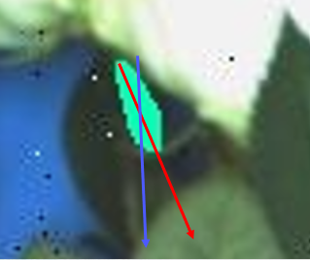  Blue: real stem direction; Red: PCA calculated direction  (1) filter out small segmentation when pixels < 100  (2) Add filtering condition when pairing:  Stem A as base stem, if Stem B is its best candidates with lowest score b, we must check, for Stem B as the base stem, Stem A score a should be not much different from Stem B score b.  If abs(a - b) > 30, this is a false pairing. Then Stem A has to move to the second best candidate and iterately check the if the filter condition is satisfied.  But this will lead to another type of false pairing, here is the example:  Base Stem A found the best candidate Stem B with score 53, but the score_a from Stem B is 9, so abs(a - b) < 30 fails. Stem A moves to the second best candidate Stem C with score 95, while the score_a from Stem C is 75, abs(a - b) < 30 is satisfied. Thus, Stem C is paired with Stem A.  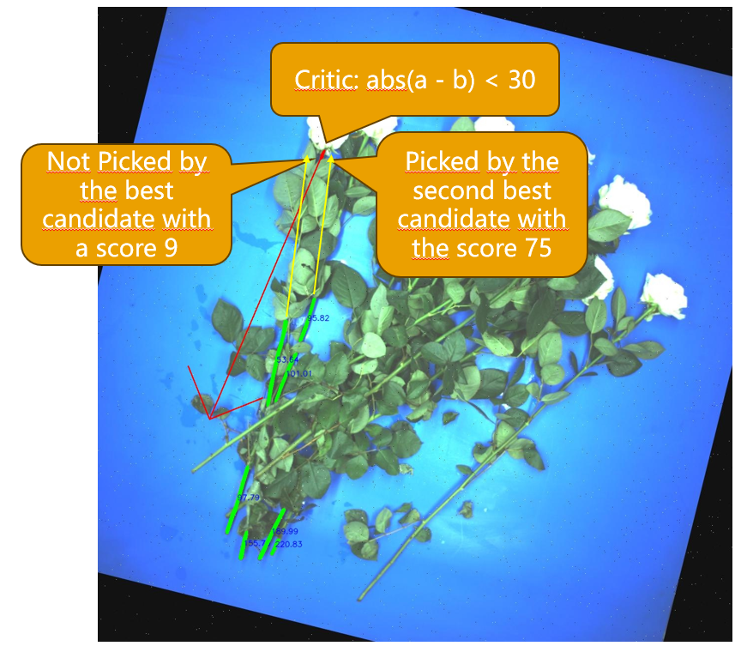  Additionally, a Fallback Strategy is complemented:  If abs(a - b) < 30 fails and the second (or so on) candidate is picked, a_current (from Stem C) should not be larger than a_previous (for all previous candidate, Stem B for example).  If all later candidates fail this critic, fallback and pick the candidate (with lowest a + b) | for score_ij, c2, j in candidates_sorted:  score_ji = score_map.get((j, i), float('inf'))  valid_pairs.append((j, score_ij, score_ji))  if abs(score_ji - score_ij) <= diff_thresh:  if (not prev_scores) or (score_ji < min(prev_scores)):  print(f"stem {j} is picked by stem {i} for score_{i}_{j} = {score_ij} and score_{j}_{i} is {score_ji}")  return j  This part now changes to:  for score_ij, c2, j in candidates_sorted:  # search j->i  score_ji = score_map.get((j, i), float('inf'))  valid_pairs.append((j, score_ij, score_ji))  if abs(score_ji - score_ij) <= diff_thresh:  if (not prev_scores) or (score_ji < min(prev_scores)):  print(f"stem {j} is picked by stem {i} for score_{i}_{j} = {score_ij} and score_{j}_{i} is {score_ji}")  return j  prev_scores.append(score_ji)  # --- fallback logic: pick the pair with smallest (score_ij + score_ji) ---  best_pair = min(valid_pairs, key=lambda x: x[1] + x[2])  j_best, score_ij_best, score_ji_best = best_pair  print(f"By fallback, stem {j_best} is picked by stem {i} for score_{i}_{j_best} = {score_ij_best} and score_{j_best}_{i} is {score_ji_best}")  return j_best
Optimization of orientation error tolerance:  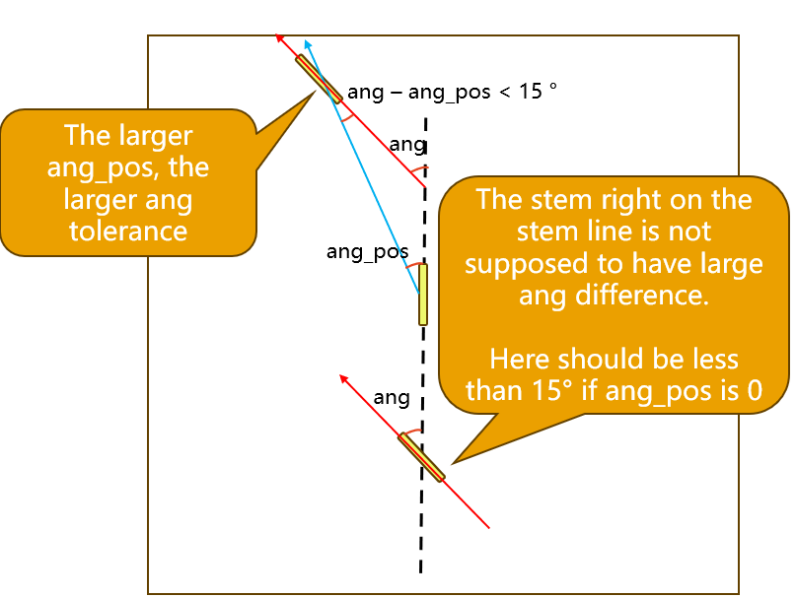  According to the base stem, each candidate has an orientation angle (ang) and position angle (ang_pos)  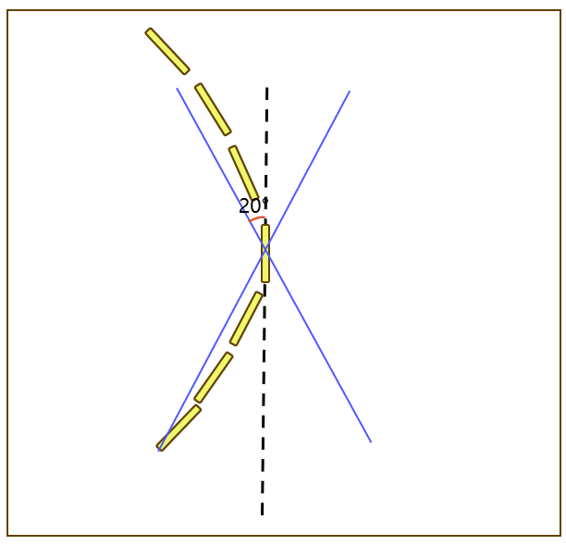  Following the bending pattern of the flower, the stem segment on the base vector is not supposed to have large orientation angle comparing to those far away.  So here we suppose ang – ang_pos shoule be less than 15 ° . This helps with filering out potential false positive candidates. | if ang-ang_pos < tol2:  valid = True
Optimization of small score strategy:  (1) If the candiate score is less than 3, only compare the distance  (2) If the score is 3 – 10, compare the score * distance  (3) Else, compare the score  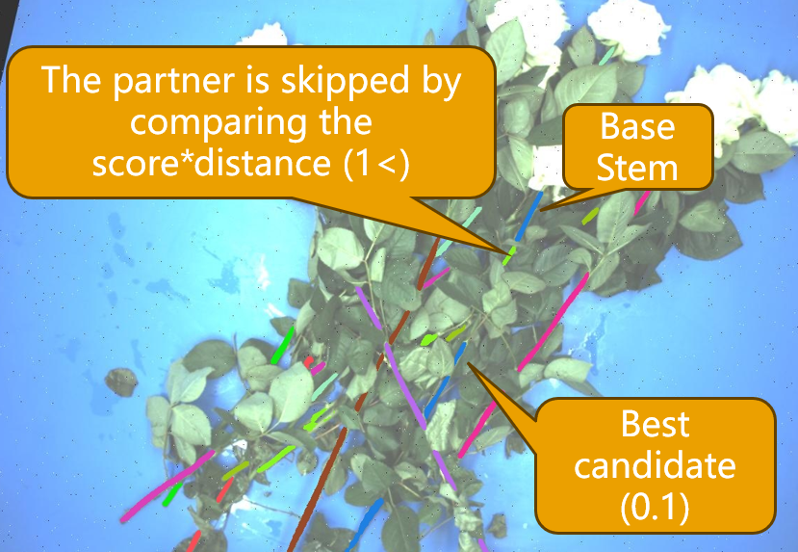  This strategy comes from this obvious error if we only compare score * distance when the score is less than 11. | 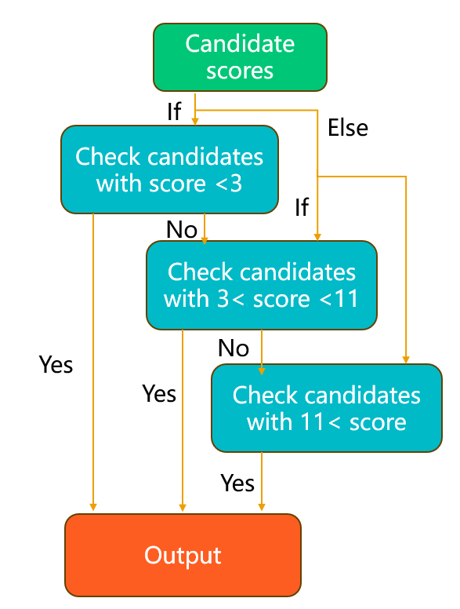  filtered = [c for c in up if c[0] < 10]  if filtered:  filtered_s = [s for s in up if s[0] < 3]  if filtered_s:  …  Else:  …
Horizontal stem problem:  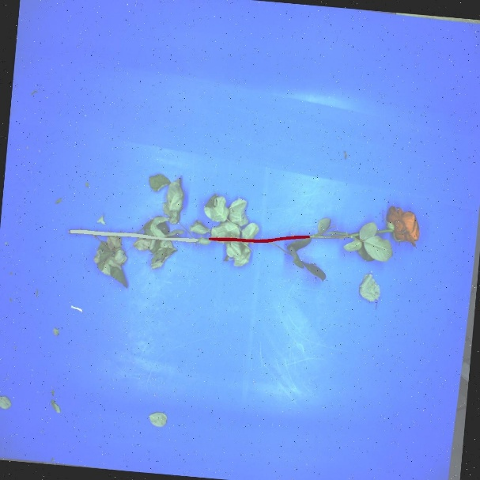  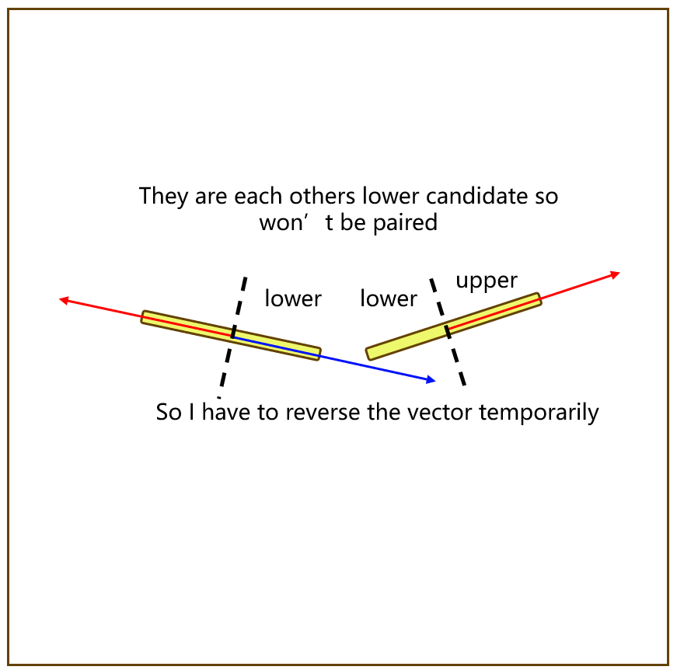  By default, each stem’s vector is set to be upwards for easy calculation.  Two stems will be paired only if they are in the opposite region of each other (upper-lower)  To prevent the issue in the image, I have to reverse the base vector during this single loop so that they won’t be at each other’s lower region. | if abs(angle_between(d1, d2)) >math.pi/2:  if i < j:  d1 = -d1  else:  d2 = -d2

